RAW QUERIES->BASED ON ENTITIES

using System;

using System.Collections.Generic;

using System.Linq;

using System.Text;

using System.Threading.Tasks;

namespace DBFirst1

{

    class Rawqueries

    {

        static void Main(string[] args)

        {

            ProdMgmtEntities db = new ProdMgmtEntities();

            IEnumerable<Product> pdlist=db.Products.SqlQuery("select * from Products where Cid=11");

            foreach(Product p in pdlist)

            {

                Console.WriteLine("{0}\t{1}\t",p.Pname,p.Category.Cname);

            }

        }

    }

}

using System;

using System.Collections.Generic;

using System.Linq;

using System.Text;

using System.Threading.Tasks;

using System.Data.SqlClient;

namespace DBFirst1

{

    class Rawqueries

    {

        static void Main(string[] args)

        {

            ProdMgmtEntities db = new ProdMgmtEntities();

            SqlParameter p1 = new SqlParameter();

            p1.ParameterName = "@id";

            p1.Value = 11;

            p1.SqlDbType = System.Data.SqlDbType.Int;

            IEnumerable<Product> pdlist=db.Products.SqlQuery("select * from Products where Cid=@id",p1);

            foreach(Product p in pdlist)

            {

                Console.WriteLine("{0}\t{1}\t",p.Pname,p.Category.Cname);

            }

        }

    }

}

NON ENTITY

ADD A CLASS MYPROD_CAT.CS

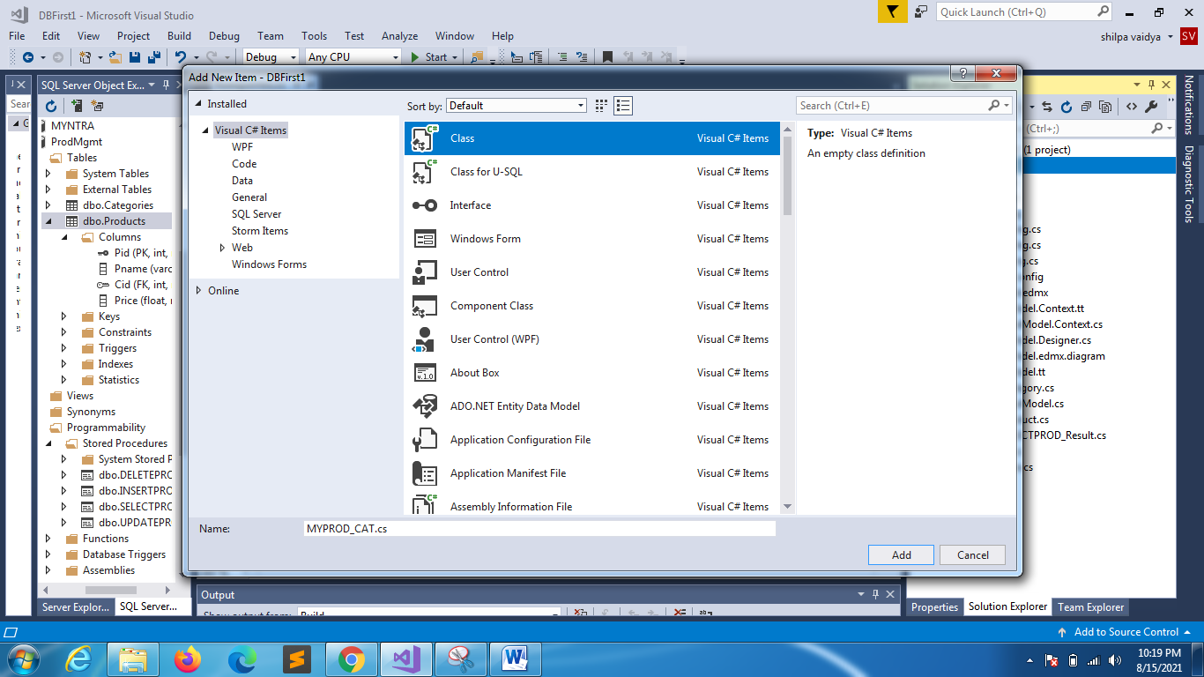

using System;

using System.Collections.Generic;

using System.Linq;

using System.Text;

using System.Threading.Tasks;

namespace DBFirst1

{

    class MYPROD_CAT

    {

        public string Pname { get; set; }

        public double Price { get; set; }

    }

}

using System;

using System.Collections.Generic;

using System.Linq;

using System.Text;

using System.Threading.Tasks;

namespace DBFirst1

{

    class RawQueries1

    {

        static void Main(string[] args)

        {

            ProdMgmtEntities db = new ProdMgmtEntities();

            var pdlist = db.Database.SqlQuery<MYPROD_CAT>("select Pname,Price  from Products");

            Console.WriteLine("NON ENTITY TYPE ");

            foreach(MYPROD_CAT m in pdlist)

            {

                Console.WriteLine("{0}\t{1}\t",m.Pname,m.Price);

            }

        }

    }

}

using System;

using System.Collections.Generic;

using System.Linq;

using System.Text;

using System.Threading.Tasks;

namespace DBFirst1

{

    class RawQueries2

    {

        static void Main(string[] args)

        {

            ProdMgmtEntities db = new ProdMgmtEntities();

            int r = db.Database.ExecuteSqlCommand("update Products set Price=999 where Pid=14");

            if(r==1)

                Console.WriteLine("Record updated");

            else

                Console.WriteLine("ERROR");

        }

    }

}